**ID – 1**

**Summary** The site https://qatesttask.mobi-dev.com is suited for mobile usage.

**Type** Functional

**Pre-conditions**

1. Opened site https://qatesttask.mobi-dev.com by using mobile Samsung A51

**Steps**

1. Click the button "Sign in"

2. Enter «55555» in the name field

3. Enter «55555» in the Last name field

4. Enter «55555» in the phone number field

**Post-conditions**

**Severity** 2

**Priority** 2

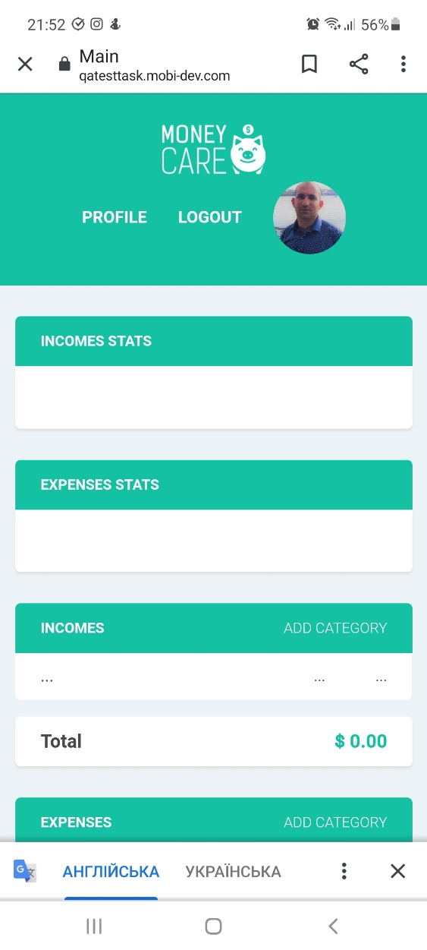**Screenshot**

**Actual result** The fields Incomes and Expenses are one under the other

**Expected result** The user can see the Incomes table in the left and Expenses table in the right below the graphs.

**ID – 2**

**Summary** The site has an intuitive and easy to use interface that allows use it instantly.

**Type** Usability

**Pre-conditions**

1. Open browser Google Chrome

2. Go to the main page of the site https://qatesttask.mobi-dev.com

**Steps**

1. Sign in. Name – 1, Password – 1
2. Click the button “NEW INCOMES CATEGORY”
3. Click the button “NEW COST CATEGORY”

**Post-conditions**

**Severity** 4

**Priority** 4

**Screenshot**

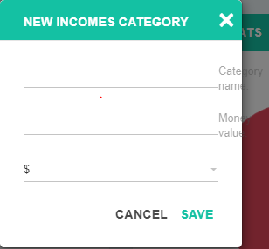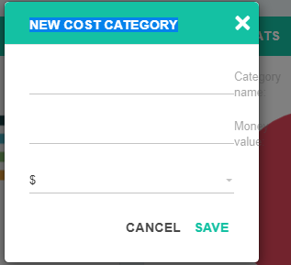

**Actual result** The names of the fields are not visible in NEW INCOMES CATEGORY

**Expected result** The site has an intuitive and easy to use interface that allows use it instantly. User cannot enter numerals in fields "Name", "Last name", the field "Phone number" can contain only 10 numerals.

**ID – 3**

**Summary** The user should “Sign up” in the system if this is his first visit to the site.

**Type** Functional

**Pre-conditions**

1. Open browser Google Chrome

2. Go to the main page of the site https://qatesttask.mobi-dev.com

**Steps**

1. Click the button "Sign in"
2. Enter “Name” 5
3. Enter “Password” 5.
4. Click “Login”
5. Click the button "Sign up"
6. Leave the fields empty
7. Leave the field "Name" empty and fill in other two fields
8. Fill in the field "Name" and leave two other fields empty
9. Enter 55555 in the field "Name"
10. Enter 55555 in the field "Last name"
11. Leave the field "Phone number" empty
12. Enter 55555 in the field "Phone number"

**Post-conditions**

**Severity** 5

**Priority** 5

**Screenshot**

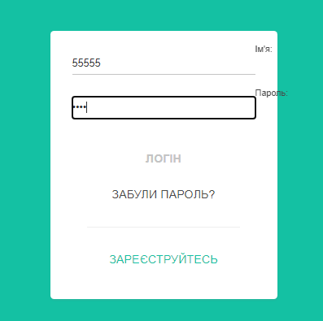

**Actual result** User can enter numerals in fields "Name", "Last name", the field "Phone number" can contain as much as you want numerals.

**Expected result** The site has an intuitive and easy to use interface that allows use it instantly. User cannot enter numerals in fields "Name", "Last name", the field "Phone number" can contain only 10 numerals.

**ID – 4**

**Summary** The user can add an avatar in any format with any size and user’s info.

**Type** Functional

**Pre-conditions**

1. Open browser Google Chrome

2. Go to the main page of the site https://qatesttask.mobi-dev.com

**Steps**

1. Enter 55555 in the field "Name"
2. Enter 55555 in the field "Password"
3. Click the button "Sign in"
4. Click the button “Profile”
5. Click “+” on photo place
6. Choose photo in PDF format 160 KB.
7. Choose photo in JPG format 657 KB.
8. Change profile fields: Name - 1, Last name - 1, Phone number – 1
9. Change profile fields: Name - empty, Last name - empty, Phone number - empty

**Post-conditions**

**Severity** 5

**Priority** 5

**Screenshot**

 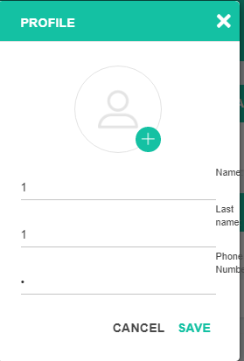

**Actual result** User can add an avatar only in format JPG, not in any format, any size and user’s info.

**Expected result** The user can add an avatar in any format with any size and user’s info.

**ID – 5**

**Summary** On “Sign in” page user can log in in the system if he is already authorized or use

**Type** Usability

**Pre-conditions**

1. Open browser Google Chrome

2. Go to the main page of the site https://qatesttask.mobi-dev.com

**Steps**

1. Enter 55555 in the field "Name"
2. Enter 55555 in the field "Password"
3. Click the button "Sign in"

**Post-conditions**

**Severity** 3

**Priority** 3

**Screenshot**

 

**Actual result** User can “Sign in” page, user can log in in the system if he is already authorized or use, but instead of “Last name” there is a field “Password”, it means, that in “Sign up” page and in “Profile” page the field “Last name” must be corrected into “Password”.

**Expected result** In “Sign in” page user can log in in the system if he is already authorized or use

**ID – 6**

**Summary** If the user forgot the password, he/she can use the button “Forgot password” for password recovery and set a new one in the form.

**Type** Functional

**Pre-conditions**

1. Open browser Google Chrome

2. Go to the main page of the site https://qatesttask.mobi-dev.com

**Steps**

1. Enter 55555 in the field "Name"
2. Enter the button “Forgot password”
3. In the field "E-mail" enter invalid data "ertyuio"
4. In the field "E-mail" enter invalid data "ertyuio@ghj.com"
5. In the field "E-mail" enter valid data "leskapavlyuk@gmail.com"

**Post-conditions**

**Severity** 4

**Priority** 4

**Screenshot**



**Actual result** The “Password” cannot be send to valid Email adress "leskapavlyuk@gmail.com"

**Expected result** The “Password” must be send to valid Email adress "leskapavlyuk@gmail.com"

**ID – 7**

**Summary** Basic income categories: Credit Card, Bank Account, Cash, Other

**Type** Usability

**Pre-conditions**

1. Open browser Google Chrome

2. Go to the main page of the site https://qatesttask.mobi-dev.com

**Steps**

1. Enter 55555 in the field "Name"
2. Enter 55555 in the field "Password"
3. In the table incomes click the button " ADD CATEGORY"

**Post-conditions**

**Severity** 3

**Priority** 3

**Screenshot**

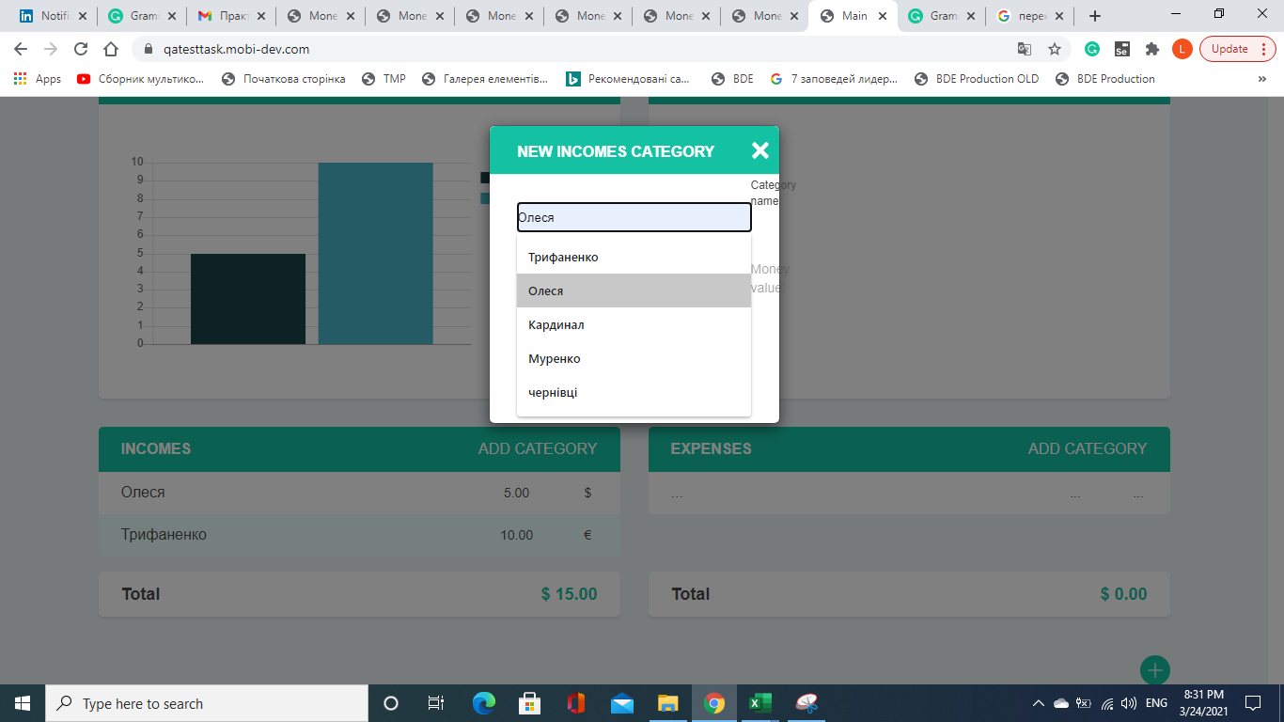

**Actual result** There are no basic income categories: Credit Card, Bank Account, Cash, Other.

**Expected result** There are basic income categories: Credit Card, Bank Account, Cash, Other in the table incomes

**ID – 8**

**Summary** Basic expenses categories: Rent, Food, Transport, Vocation, Other

**Type** Usability

**Pre-conditions**

1. Open browser Google Chrome

2. Go to the main page of the site https://qatesttask.mobi-dev.com

**Steps**

1. Enter 55555 in the field "Name"
2. Enter 55555 in the field "Password"
3. In the table expenses click the button " ADD CATEGORY"

**Post-conditions**

**Severity** 3

**Priority** 3

**Screenshot**

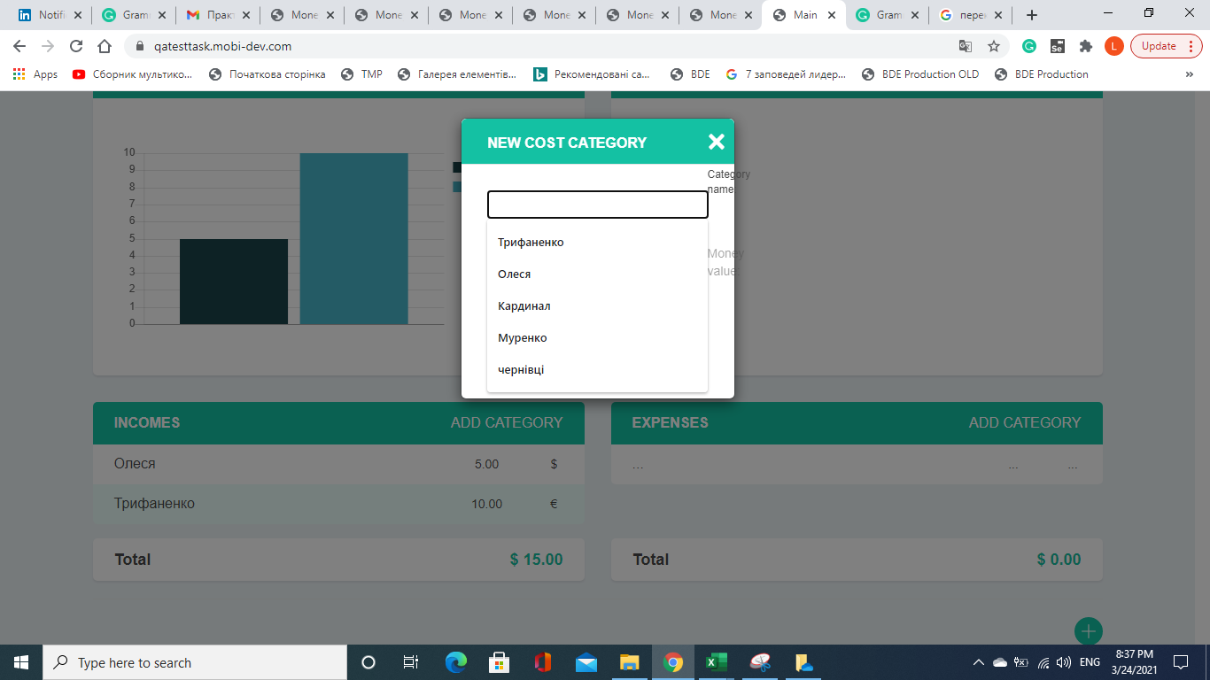

**Actual result** There are no basic expenses categories: Credit Card, Bank Account, Cash, Other. There is a mistake in requirements instead of “expenses” there is a word income. And in the table expenses when user chooses the category, the name of table categories there must be “NEW EXPENSES CATEGORY”.

**Expected result** There are basic expenses categories: Credit Card, Bank Account, Cash, Other in the table incomes

**ID – 9**

**Summary** Total value is depended on the type of currency and is placed under the tables in a separate block for user convenience

**Type** Logical

**Pre-conditions**

1. Open browser Google Chrome

2. Go to the main page of the site https://qatesttask.mobi-dev.com

**Steps**

1. Enter 55555 in the field "Name"
2. Enter 55555 in the field "Password"
3. In the table incomes click the button " ADD CATEGORY"
4. Enter “Трифаненко” in the field "Category name"
5. Enter “50” in the field "Money value"
6. Choose $ in the field "Currency"
7. Click the button "Save"
8. Enter “Олеся” in the field "Category name"
9. Enter “60” in the field "Money value"
10. Choose € in the field "Currency"
11. Click the button "Save"

**Post-conditions**

**Severity** 5

**Priority** 5

**Screenshot**

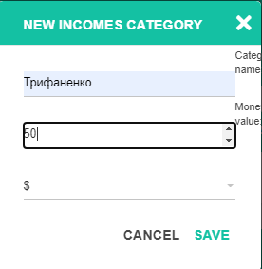 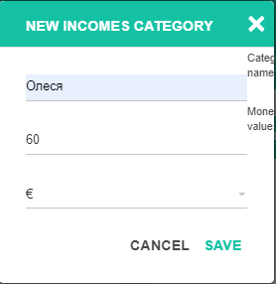

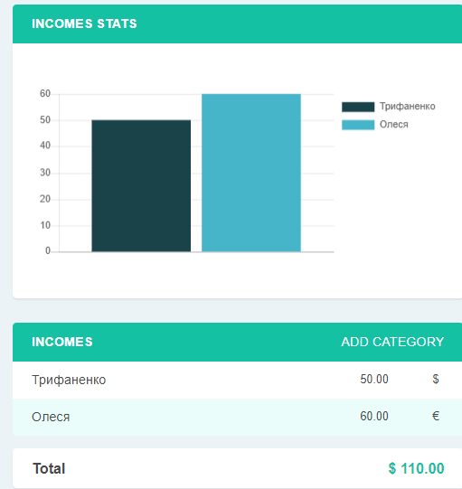

**Actual result** Total value is not dependent on the type of currency, there are two different currency and there must be a total with all types of currency separately.

**Expected result** Total value is depended on the type of currency and is placed under the tables in a separate block for user convenience